

17 July, 2019

**Web and Mobile Application for CXB WASH Program**

**User Manual**

**Version: 1.0.0**

Table of Contents

1. General Information 3

1.1. Intended audience: 3

1.2. Version Compatibility 3

1.3. General Security 3

1.4. Application Information 3

1.4.1. Web Application 3

1.4.2. Mobile Application (Only for data collectors) 3

2. Overview 4

3. Registration 4

3.1. Sign-up Instruction 4

3.2. User Activation (Only for system administrator) 5

3.3. User Settings 6

3.3.1. Edit User Information 7

3.3.2. Delete User 9

3.3.3. Reset Password 9

3.3.4. Disable User 10

3.4. Login 11

4. Beneficiary Card 11

5. SMS 12

6. Event Calendar and Reporting 14

6.1. Calendar 14

6.2. Report 16

7. Field Reporting Module- Authorization Setup 17

8. Field Reporting- Execution and Approval Process 19

8.1. Community 19

8.2. Union 22

# General Information

## Intended audience:

This document has been prepared with intended audiences who would be a registered user of the CXB WASH application with permission on the web application.

## Version Compatibility

This version of the user manual (version 1.0.0) is compatible with the web application version: 2.5.12. Any further changes on the system may or may not match with this version of the document.

## General Security

All the audiences of this document are requested not to share the user credentials of the CXB WASH M&R system to any other person unless instructed by the respected supervisors.

## Application Information

The CXB WASH M&R system is divided into two platforms: Web Application and the Mobile Application.

### Web Application

To access the web application, please complete the steps provided below.

1. From any device, open web browser.
2. Provide the following url- <https://cxb-wash.info/>
3. If you are a registered user provide credentials and login

### Mobile Application (Only for data collectors)

From any android device,

1. Go to google play store
2. On the search box type ‘CXB WASH’
3. From the provided list download the CXB WASH application
4. After the download is complete, please install the app

**Caution:**

If you are not a data collector, please never login into the mobile application; unless, instructed by the respective supervisors. Download of excessive data might damage your device.

# Overview

CXB WASH project aims to improve the health, nutrition and wellbeing of the vulnerable population in 14 rural districts especially women and girls through sustained use of safe water supplies, sanitation services and sustained adoption of hygiene practices.

This system creates a user-friendly monitoring and reporting platform that is required for easy data and information entry by different users, real-time compilation, filtering and custom report generation. It will facilitate different reporting process of UNICEF field offices and also support transferring of existing Excel and Word-based information into the web platform and user support in system deployment.

# Registration

Registration is required for all level of users to get started.

## Sign-up Instruction

1. For public registration go to CXB WASH.streamstech.com. Click on **Signup** button on the bottom.

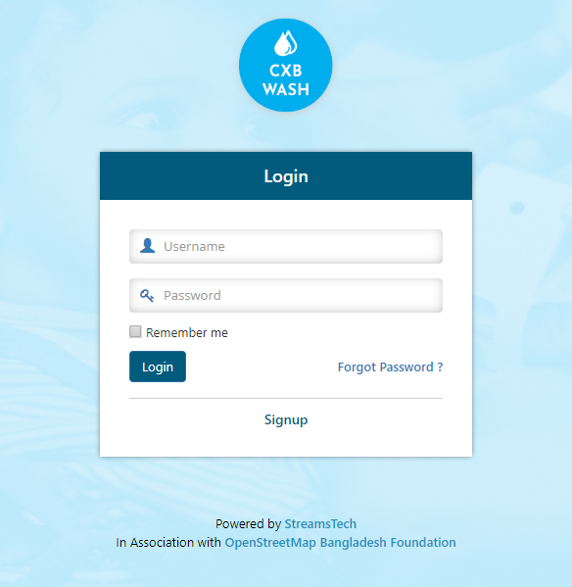

Signup

Figure : Sign-up screen

1. Give user information. Choose a unique username and email (required for login). Select your organization from the list and click on **Signup** button.

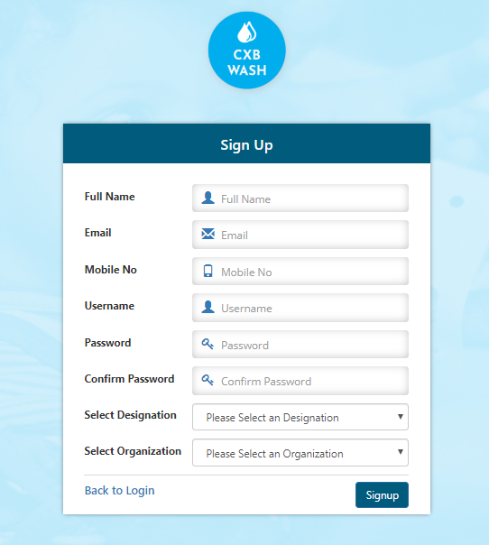

Figure : Sign-up window

## User Activation (Only for system administrator)

1. Go to CXB WASH web portal. Login as system administrator.



Figure : Login as system administrator

1. Go to Admin → User Management → Registered User.
2. At this stage a list of registered users from your organization will be displayed. Find the registered user and click on **Enable** button as shown on Figure 4. Now the user will be ready to use the system

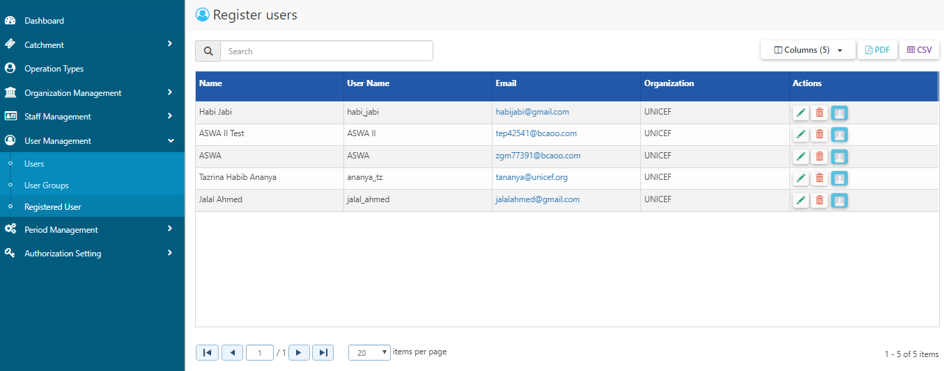

Enable

Figure : Enable user from Registered User

## User Settings

1. Next you can find the enabled user on users list. From this section you can edit user information, delete user, reset password, send SMS or disable the user

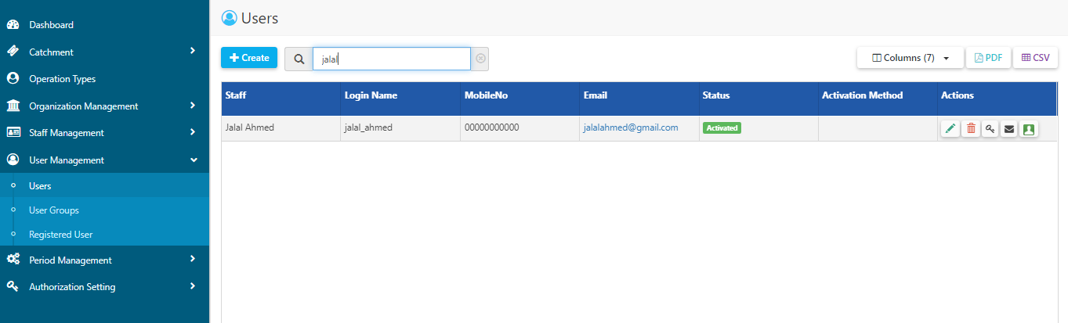

Edit

Delete

Reset Password

Disable

Figure : User settings and controls

### Edit User Information

1. User information can be edited from edit control.



Edit

Figure : Edit Control

1. Clicking on **Edit** button will open the form below. Primary information including login name, mobile and email can be edited from this form.

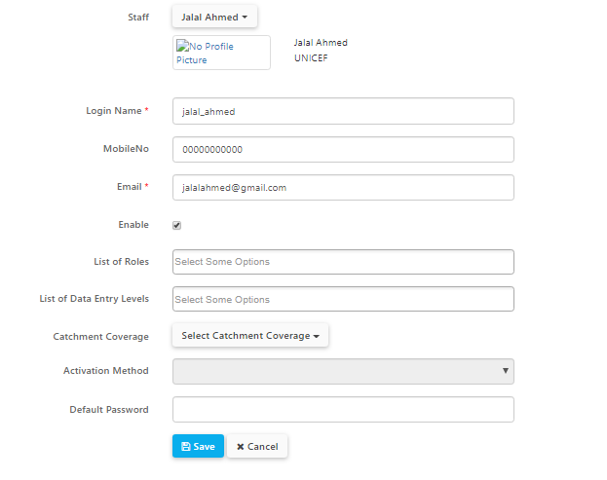

Figure : Edit user information

1. ***Catchment Permission***

**Catchment Coverage** will give the user catchment permission. The user will not be able to collect data on the area that does not cover the catchment.

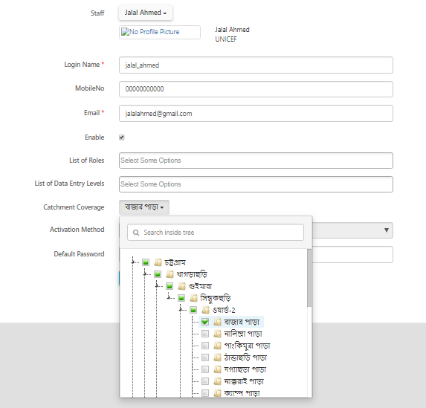

Figure : Catchment Permission

1. ***User Role***

Set user role from the list of roles.

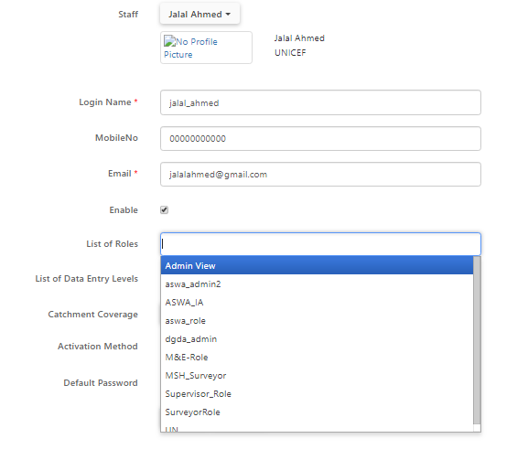

Figure : User Role

### Delete User

1. Delete user will allow to delete the user from the system. User will no longer be able to login after deletion.



Delete

Figure : User delete control

### Reset Password

1. To change the password of the user, click on **Reset Password** button. Give the new password and retype. Save afterwards.

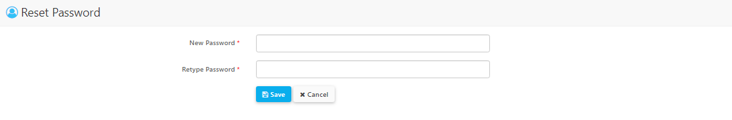

### Disable User

1. To disable the user temporarily, click on **Disable** button. This user will not be able to login unless s/he is enabled again.

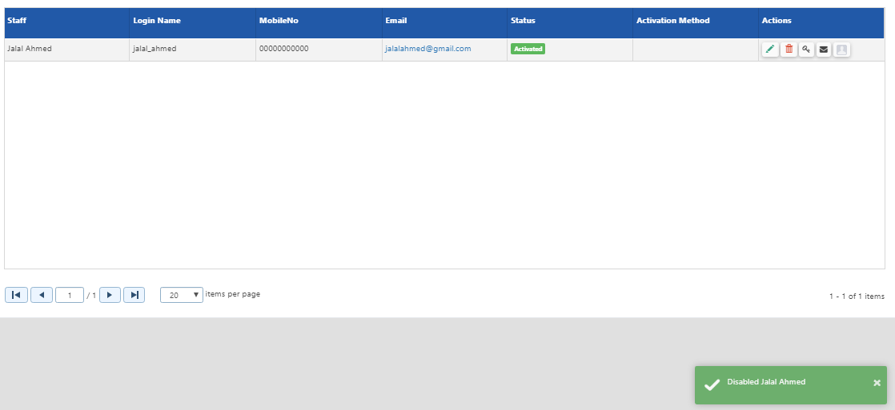

Disable

Figure : Disable user

## Login

1. After activation from admin panel user can login successfully using username and password.

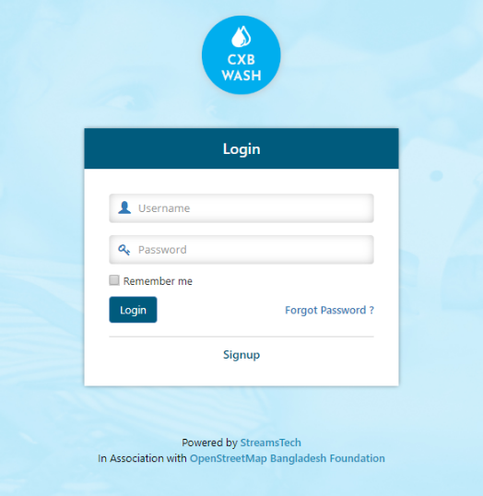

Figure : Login as user

# Beneficiary Card

1. To print beneficiary card go to Beneficiary Card module → Print Smart Cards.

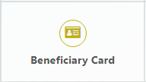

Figure : Beneficiary Card module

1. Select a catchment and click on **Show** button. A list of registered households will be displayed. User can search a household by household ID or Household Serial Number.

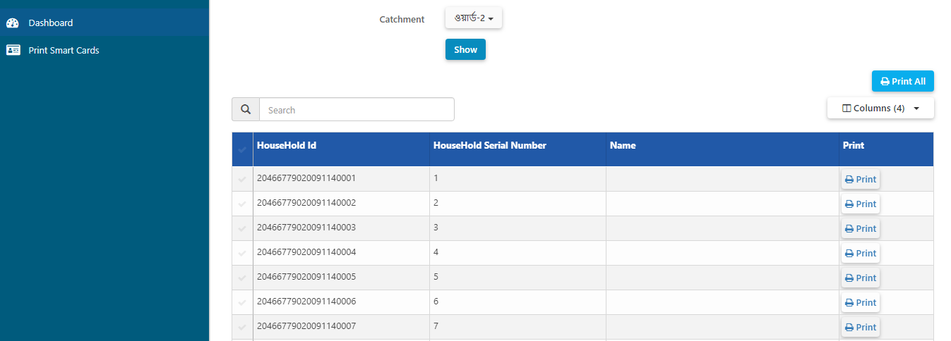

Select a catchment

Search household here

Click on Show

Figure : List of registered households

1. To print multiple cards at a time, select the households and click on **Print All** button. Else, simply click on **Print** on the row for single print.

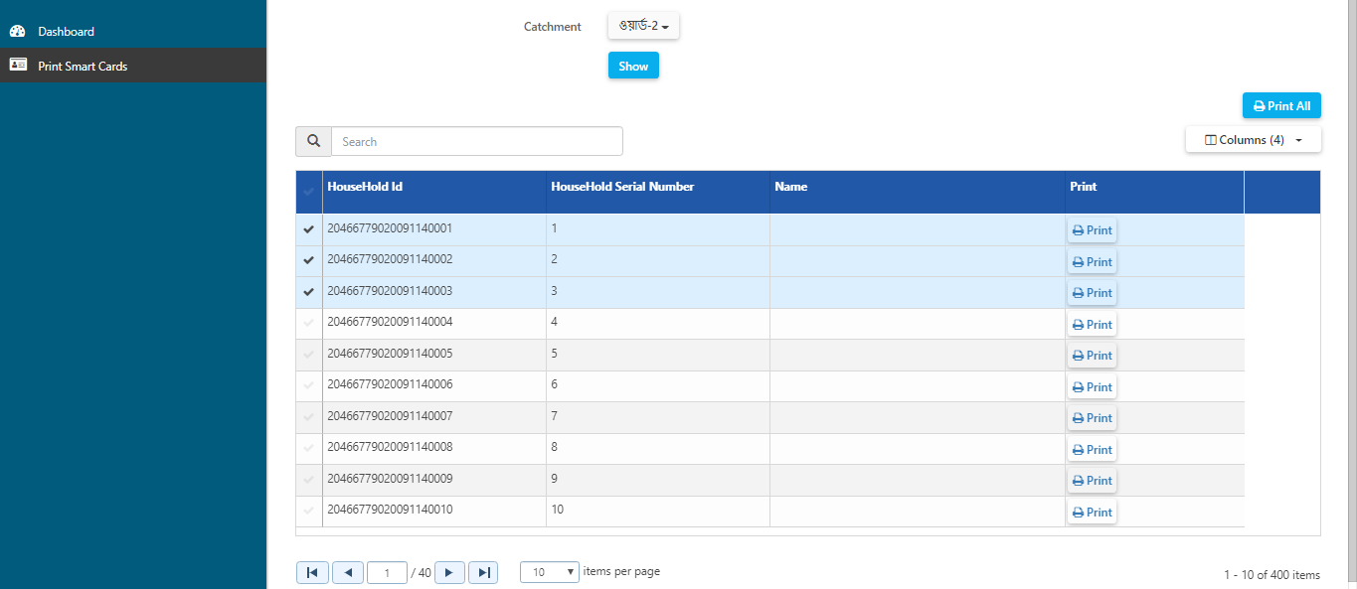

2. Click on Print All

Click on Print for single print

1. Select multiple households

Figure : Print beneficiary cards

# SMS

1. Users with SMS module permission will be able to send bulk SMS to a user or a group of user from SMS module. Go to SMS module → Send SMS to User.

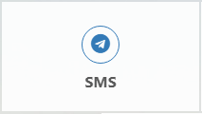

Figure : SMS module

1. Select the single or multiple users who you want to send bulk SMS.

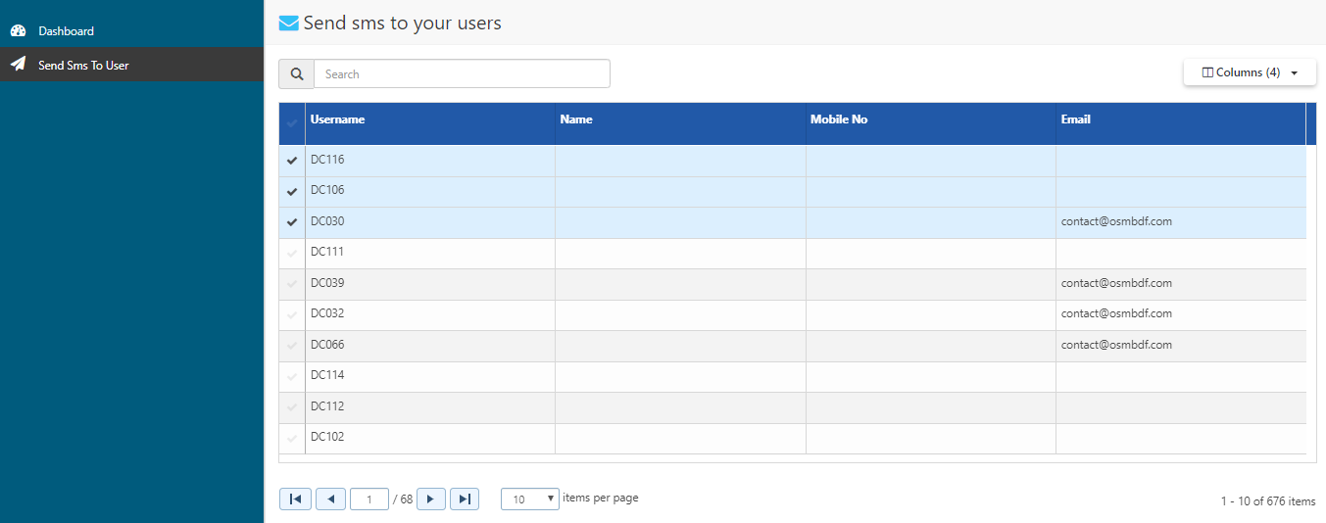

Select the users

Figure : Select users

1. Write the **Message** on the message box and **Send.**

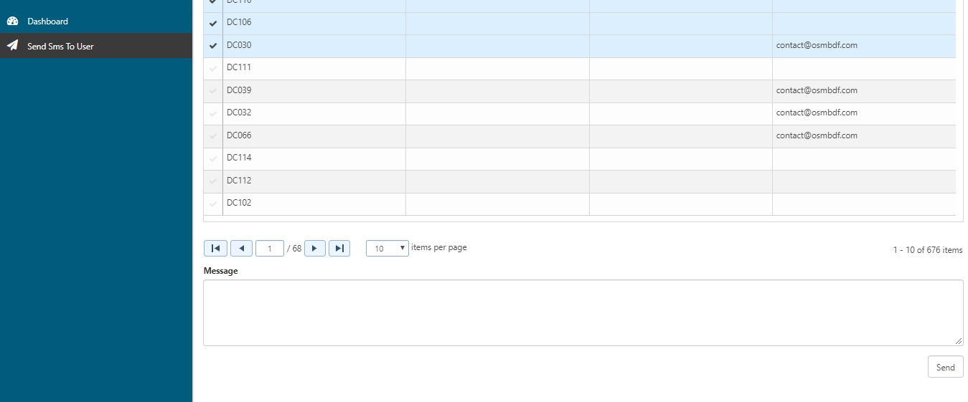

Type message here

Send

Figure : Write message

# Event Calendar and Reporting

## Calendar

1. Go to CXB WASH web portal. And login with a user who has access to **Event Calendar** module. Next go to Event Calendar → Calendar.

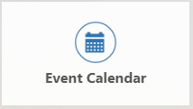

Figure : Event Calendar module

1. Go to a desired date using arrow (**<>**) buttons on the upper right corner of the calendar. Select a **Catchment** to view all the existing events on that catchment on the month.

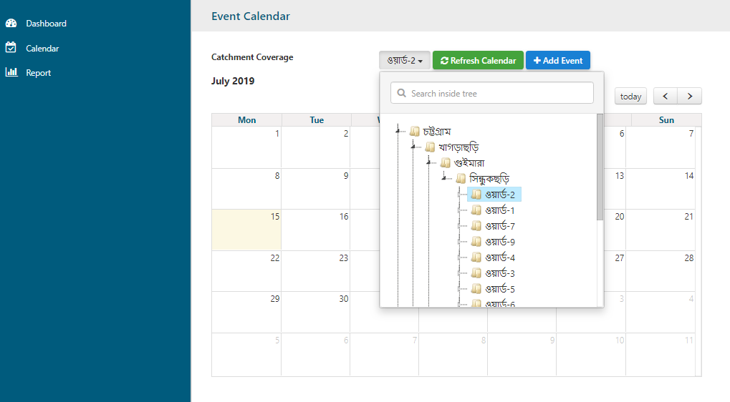

Arrow buttons

Choose Catchment

Figure : Event Calendar

1. Click on an event to view **Event Details.**
2. On the right side of the screen, the Event details would appear.
3. Please note that the Events can only be edited or deleted from the **Edit** and **Delete** buttons below by the user who has created the event.

Any other user, would only be able to view the message in read-only mode.

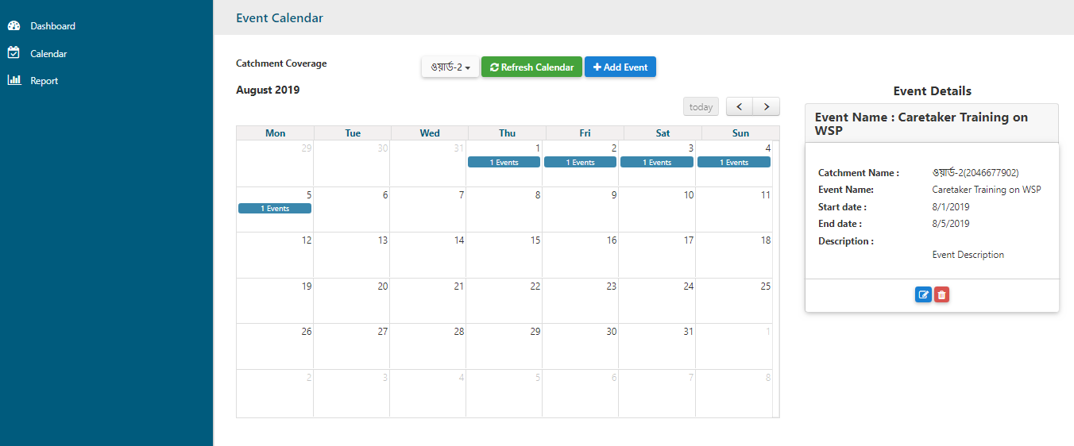

Click on an event to view event details

Delete Event

Edit Event

Event Details

Figure : Event details

1. To add an event, click on **Add Event** button.



Add Event

Figure : Add Event

1. Clicking on **Add Event** will open a dialogue box. Choose event type, event start and end date. Write event description (optional) and save afterwards.

Event type

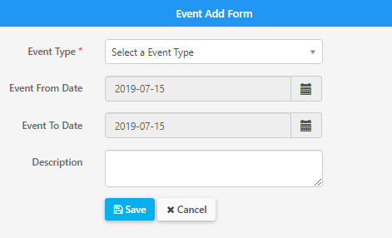 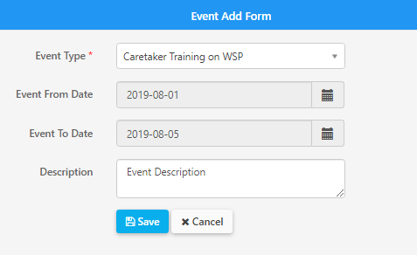

Event description

Save

Figure : Event add form

## Report

1. To view report of the events, go to report. Select a catchment and choose a start and end date. Next click on **Show Report** button. All the events on given date range for the particular catchment will be displayed on the table below.

Catchment

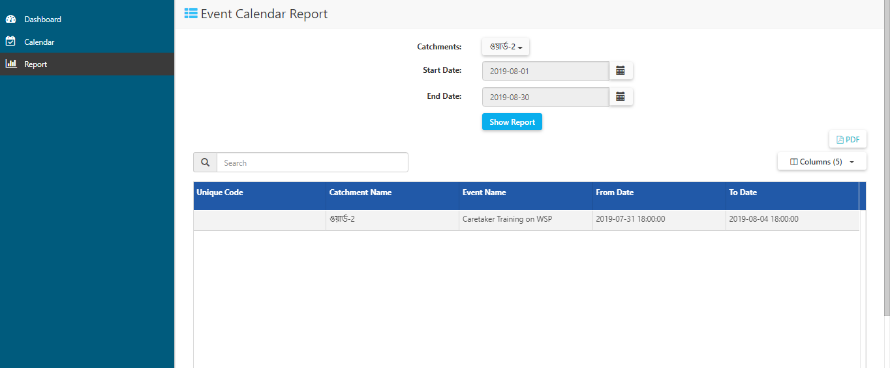

Show Report

Figure : Event Calendar Report

1. Click on **PDF** button on the upper right corner, to export the data on pdf format.



Export PDF

Figure : Export PDF

1. Uncheck unwanted columns to filter the table and export the filtered data.

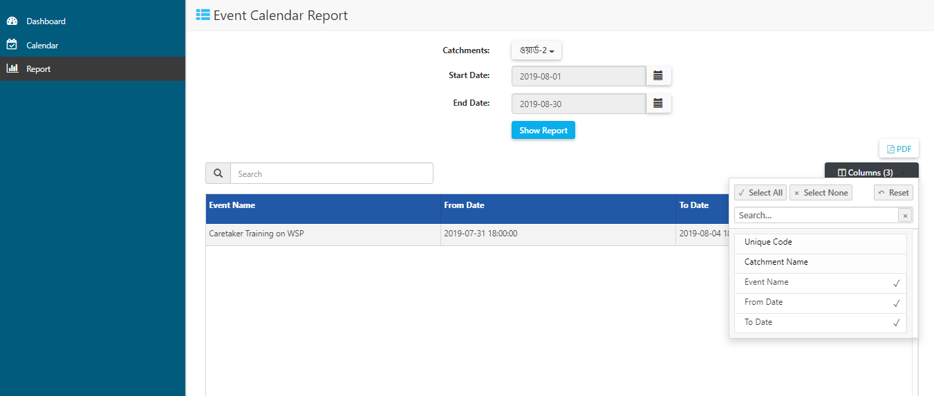

Uncheck unwanted columns

Figure : Event Calendar Columns filter

# Field Reporting Module- Authorization Setup

Authorization chain will determine the data submission, approval and rejection flow. Community Level User will submit data to immediate higher level user on the chain.

1. To add new chain on authorization flow, go to Admin → Authorization Setting → Authorizations. Choose the ‘CXB WASH Auth Flow’.

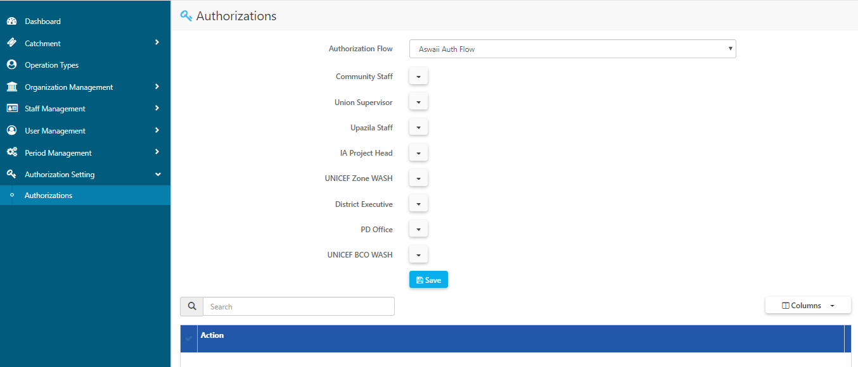

Choose an authorization flow

Figure : Authorization Flow

1. Assign appropriate users on appropriate levels.

**Point to be noted**:

When a User is assigned to a level, that specific user cannot be on other levels on different chains.

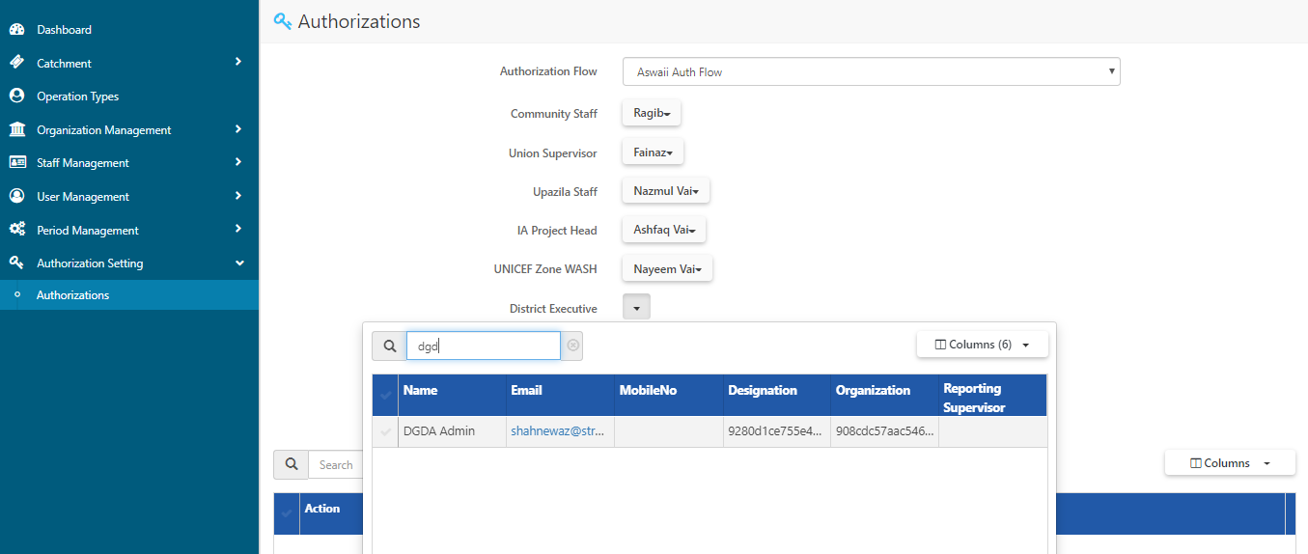

Choose every level of users

Figure : Choose different level of users

1. Save the chain. Defined chain will be added on the table below.

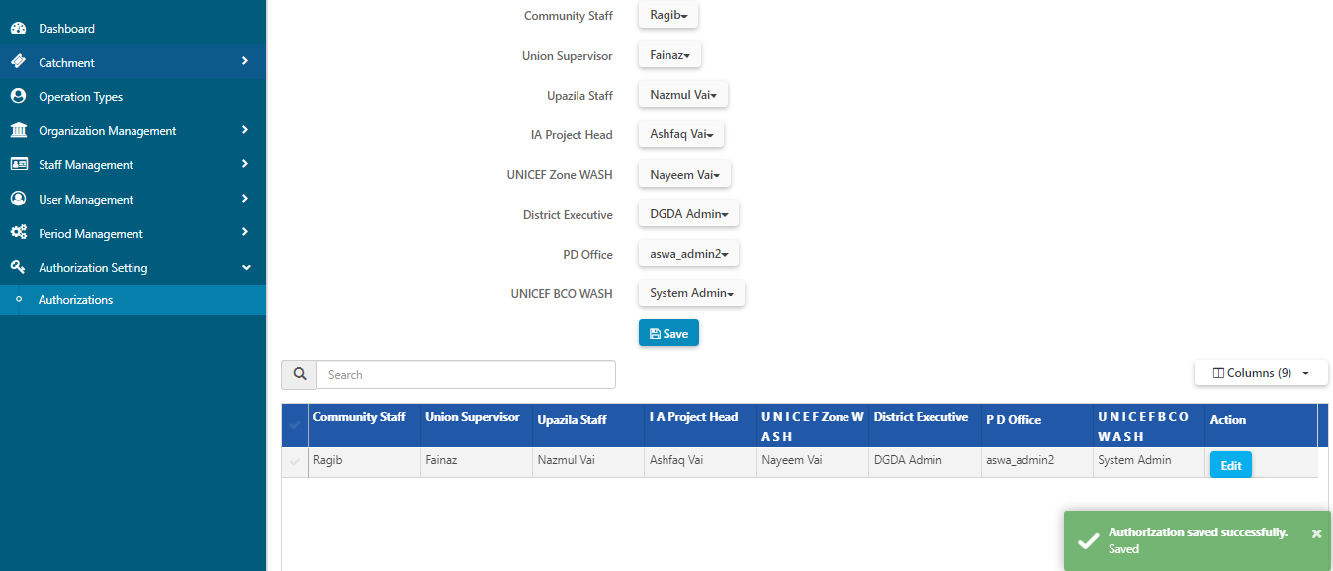

Saved chain has been added on the table

Save

Figure : Save and Create authorization chain

**Field Reporting** will be authorized according to this defined chain.

# Field Reporting- Execution and Approval Process

## Community

1. This module allows the user to collect and review data on community level. To collect data on community level, go to **Field Reporting** module.

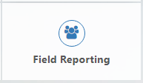

Figure : Field Reporting module

1. From this module go to Sanitation & Hygiene → Community. Select a lowest level catchment and choose an operation period.

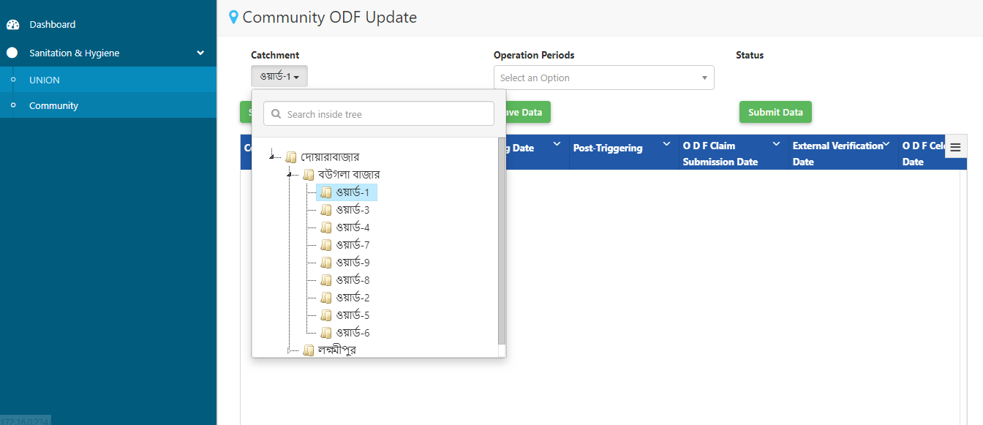

Select operation period

Select lowest level catchment

Figure : Insert Catchment and operation period

1. Click on **Show Data** to open datasheet. This datasheet is now on **Not Submitted** status.

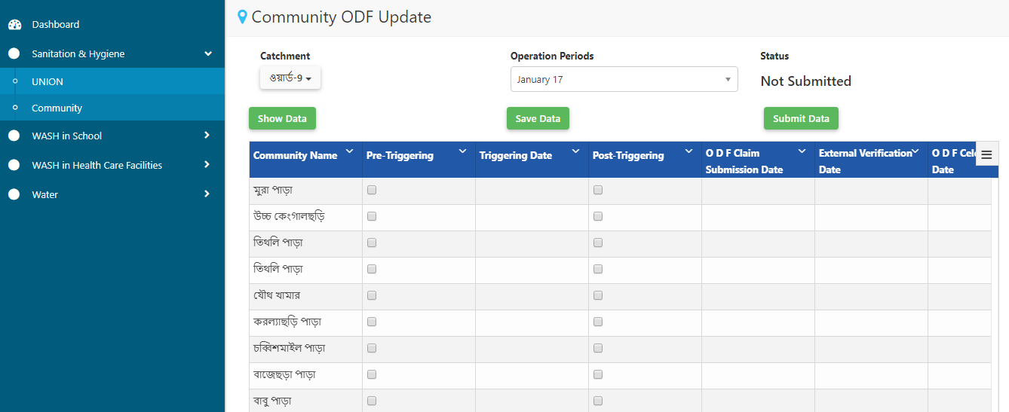

Not Submitted status

Figure : Not submitted status

1. Enter data and **Save Data.** This data will be on saved status, can be edited and will not be available to the next level of user for review.

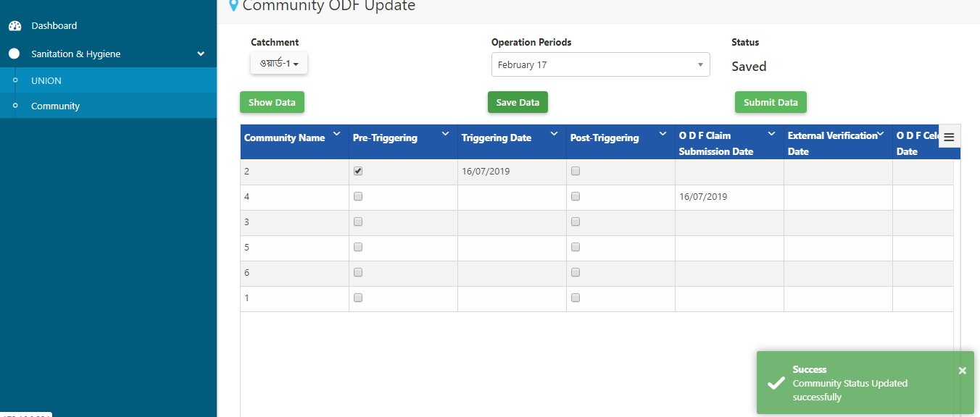

3. Save data

4. Saved status

5. Submit data

2. Enter data

1. Show data

Figure : Collect and Save data

1. To submit the data to the next level user, click on **Submit Data (5).** Point to be noted, data cannot be edited further after submission.

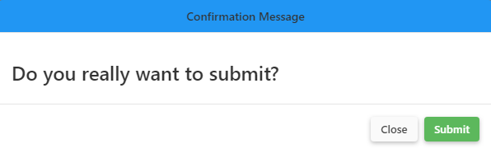

Figure : Submit data

1. Data will be now on **Submitted** status and will be available to the next level user.

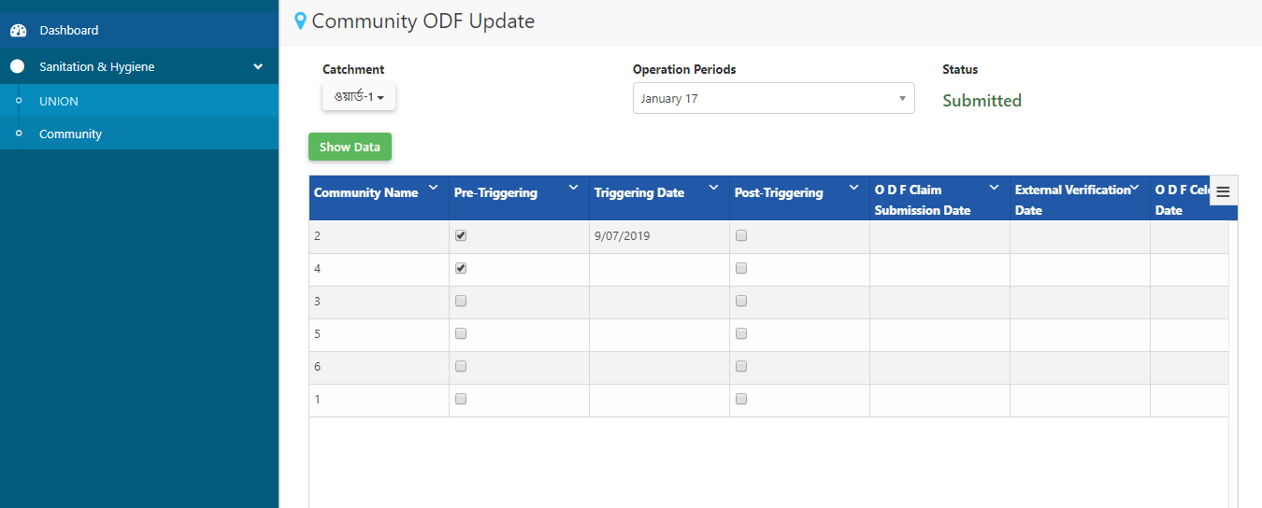

Submitted status

Figure : Submitted Status

## Union

1. After submission the data will be available to the UNION Supervisor on union level.
2. Select a catchment and select an appropriate Quarter.
3. Next click on **Show data**. All the data entries on the catchment within the operation period will be displayed on the table.
4. After the data has been reviewed and data entry is complete. Click on **Save** Data.

Show data

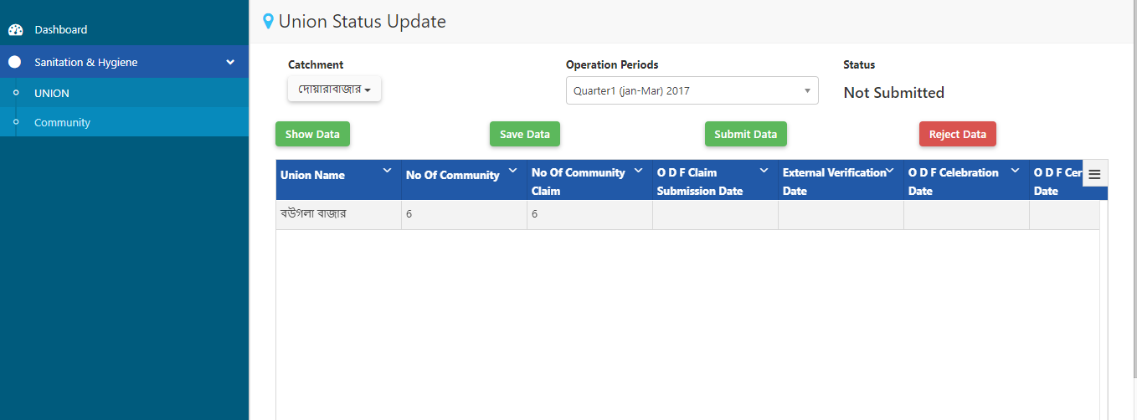

Select a catchment

Select an operation period

Figure : Union datasheet on Level 2

1. Once data entry is complete, **Submit** data from **Submit** button below.

Point to be noted, data cannot be edited after submission.

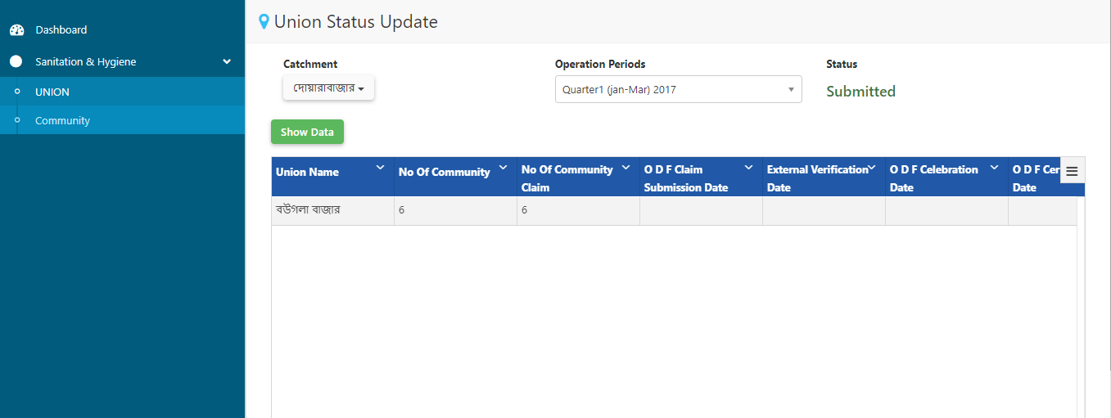

Submitted status

Figure : Union data submitted

1. The Submission would be sent to the Upazilla Staff user based on the authorization Flow.
2. To approve the submission, please go to Field Reporting Module→Sanitation and Hygiene→Union
3. Select appropriate catchment and Operation period and click on **Show Data**
4. Review the data and Approve or Reject as necessary.



Figure Union Data Entry Upazilla Staff

After the approval of the data by the Upazilla Staff, the submission would be sent to IA Project Lead. Approval from here would send the submission to the next level. Please note that the hierarchy of the authorization has been defined as follows:

*Community Staff↔ UNION Supervisor ↔ Upazilla Staff ↔ IA Project Head/ M&E Officer ↔ UNICEF Zone WASH Officer ↔ District Executive Engineer ↔ PD Office, GoB- UNICEF ↔ UNICEF BCO WASH*

Please note, as shown on the flow above, approval of the submission would send the request to the next level on the chain, whereas, rejecting the submission would send the request to the previous level.

# Survey Module

## WASH Inventory Data Approval/ Rejection

When data is collected from the field by the data collectors and synced to the server, it would require approval of the administrator or a role-based user. This is to validate the entry to restrict any form of data inconsistency.

To approve a WASH Inventory entry please complete the following steps:

1. Login in appropriate credentials
2. Go to Survey Module→ Inventory Approval

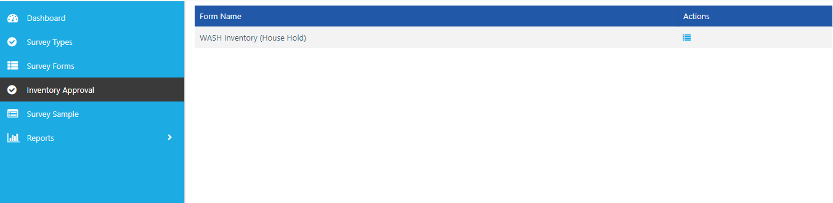

Figure WASH Inventory Approval menu

1. On the next screen, the list of pending WASH Inventory Household approval requests would be available.

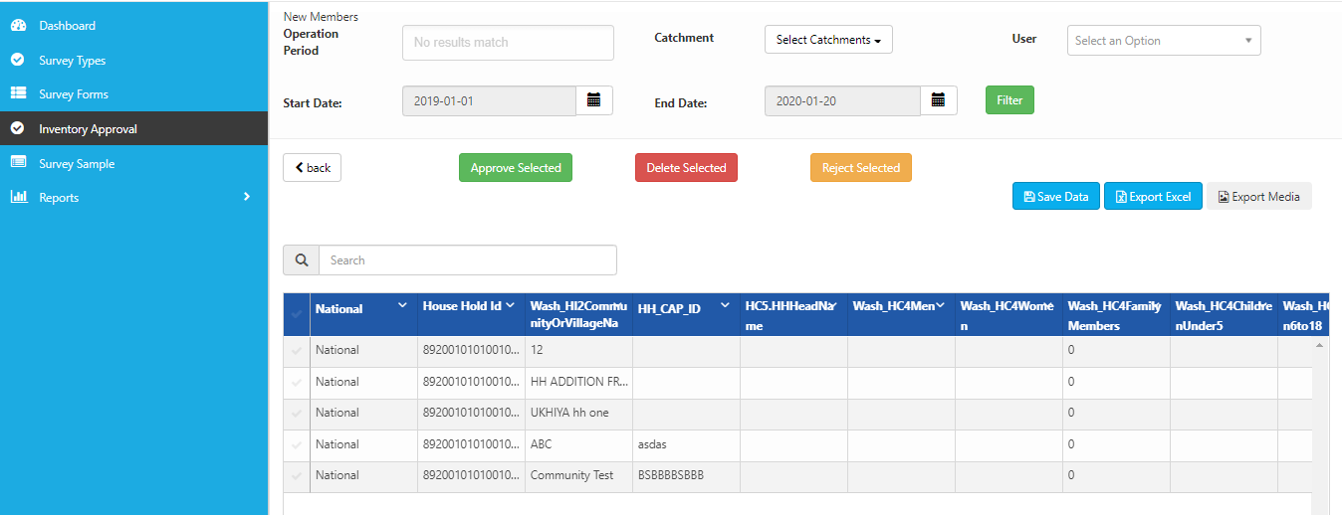

1. To approve the items, select the desired items and click on ***Approve Selected.*** To reject the item, please select ***Reject Selected.*** To delete an item, select ***Delete Selected.***

## WASH Inventory Data View and Edit

1. Once the data has been approved, to view and edit the data, please login to the web
2. Go to Survey Module→ Survey Forms→ WASH Inventory Forms

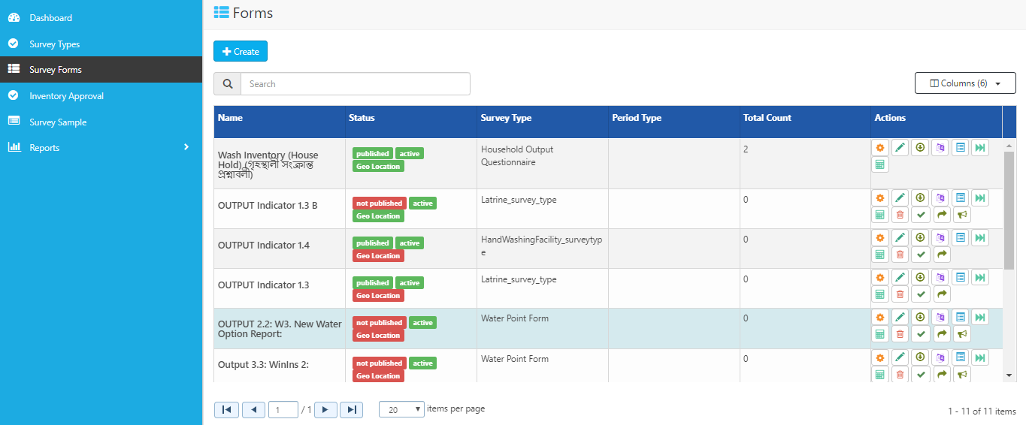

1. To view the data, on the WASH Inventory Form, Click on View Details
2. Now, select the item you want to edit and make changes to appropriate fields.